LAB# 02


Submitted by:

Submitted by:

Name | Registration No.
Muhammad Abdullah | FA24-BSE-042

Submitted to: Anayat Ullah
Course: Information security
Dated: March 1, 2026.

DEPARTMENT OF COMPUTER SCIENCE
COMSATS UNIVERSITY ISLAMABAD,
ISLAMABAD CAMPUS

Activity 1

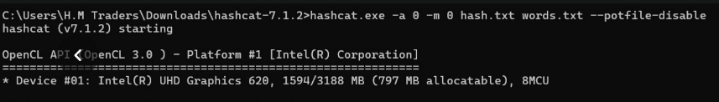

Activity 2
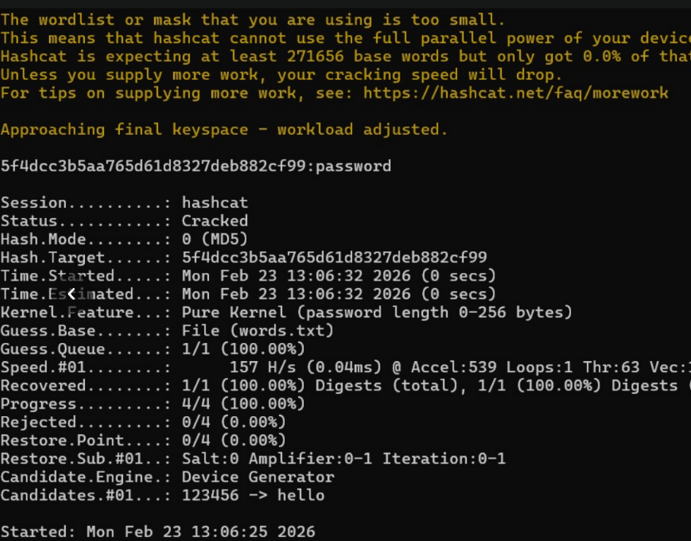

Activity 3:
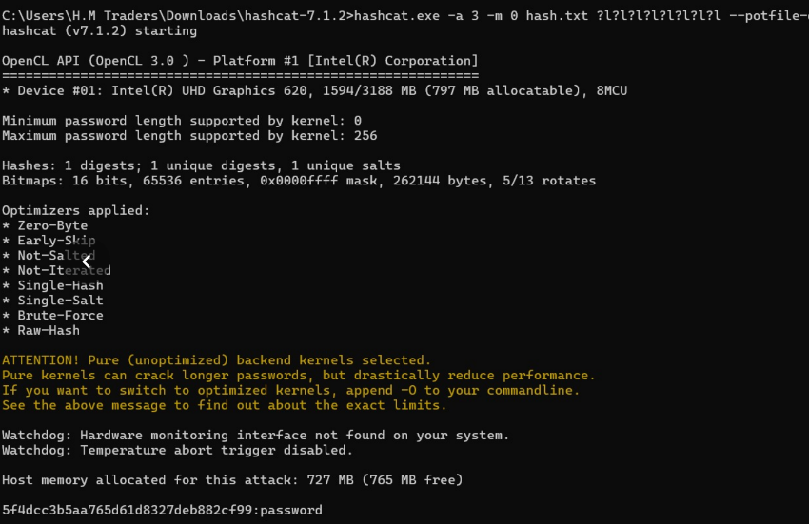

Activity :
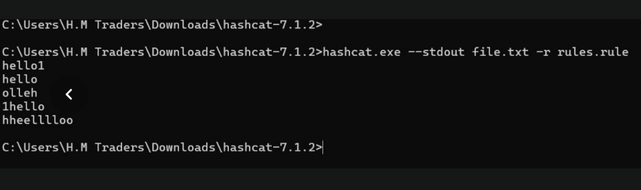

Activity 4:
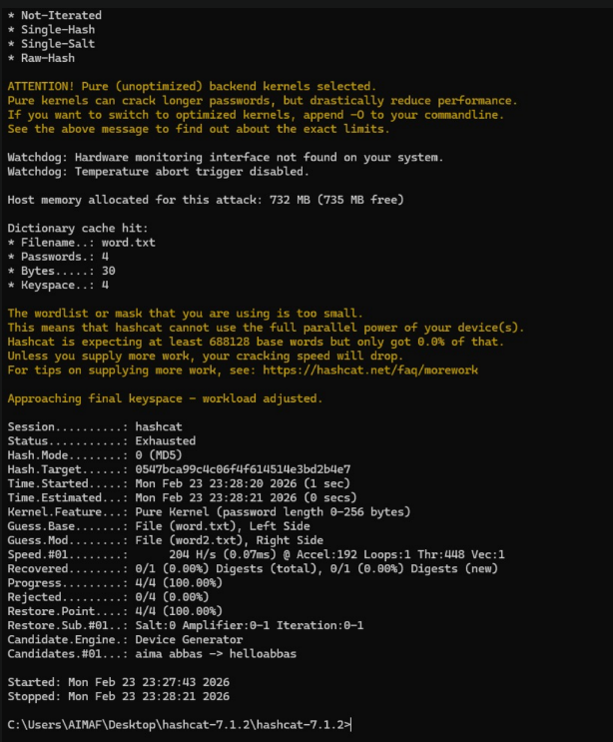

Lab Task 1

Analyze and test the security of passwords using John the Ripper
Objective:
Test how strong passwords are by attempting to crack their hashes.
What you will do:
- Create or obtain a password hash file.
- Use different cracking modes:
  - Wordlist mode
  - Wordlist + rules
  - Brute-force mode
- Compare time and effectiveness.

Lab Task 2

Install John the Ripper
On Kali Linux, it is usually pre-installed
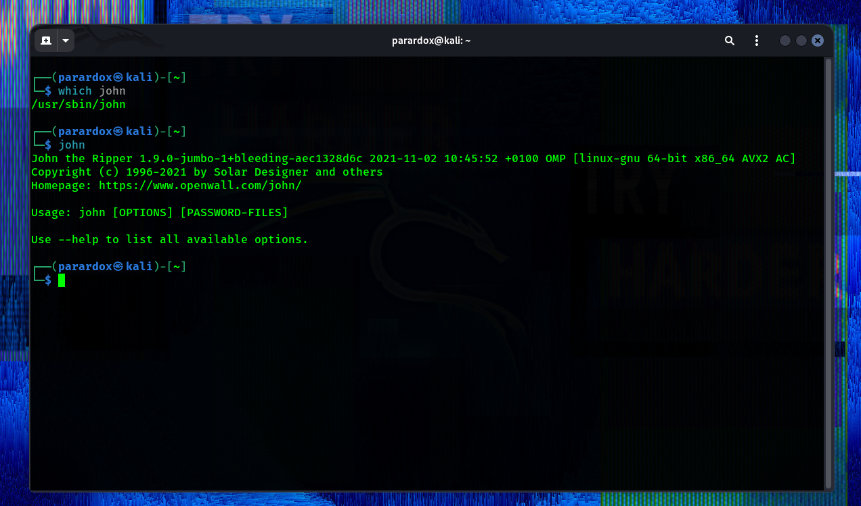

Lab Task 3

Use rockyou wordlist and crack a sample file

Step 1: Locating rockyou wordlist
In Kali:
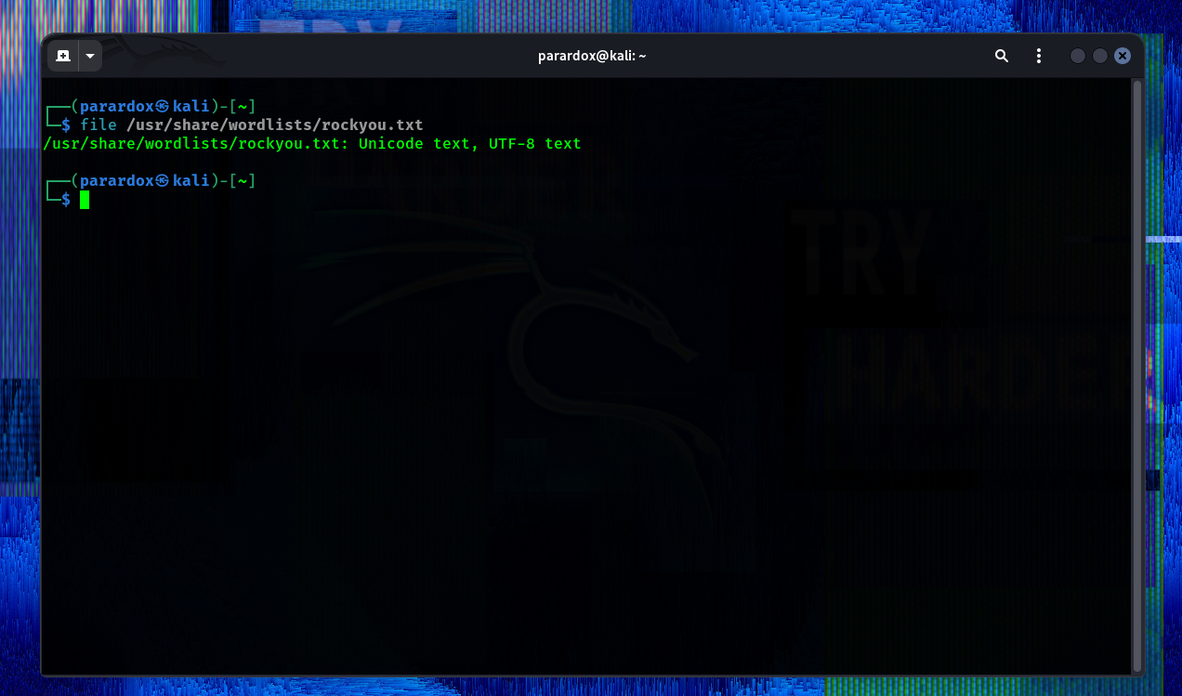

Step 2: Create Sample Password File
Create a file:
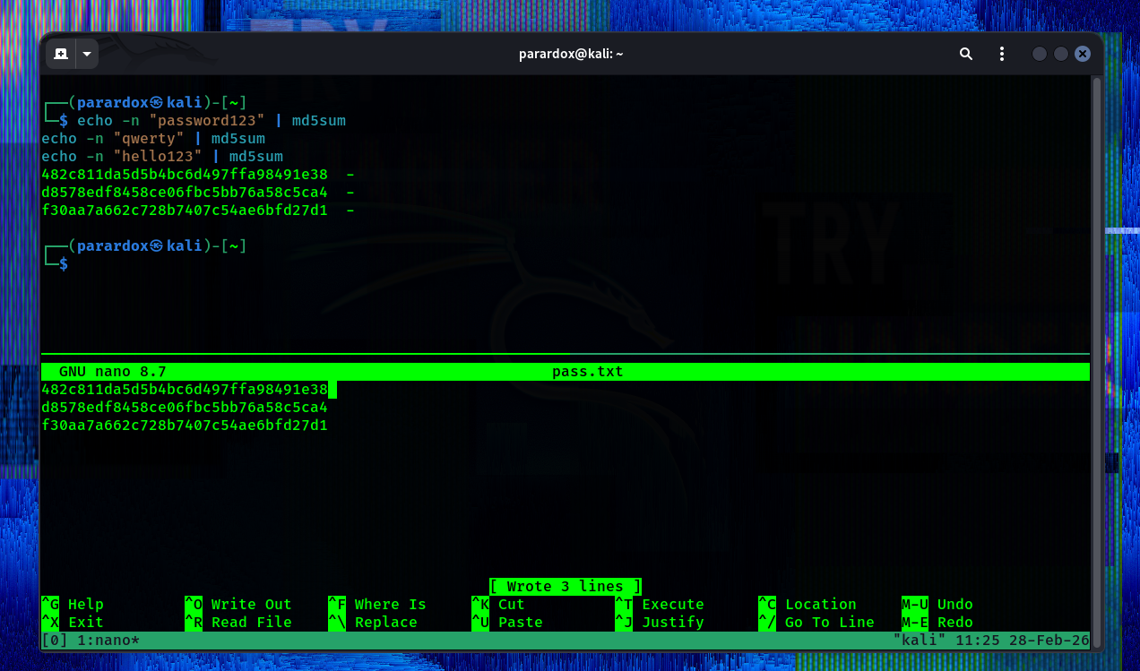
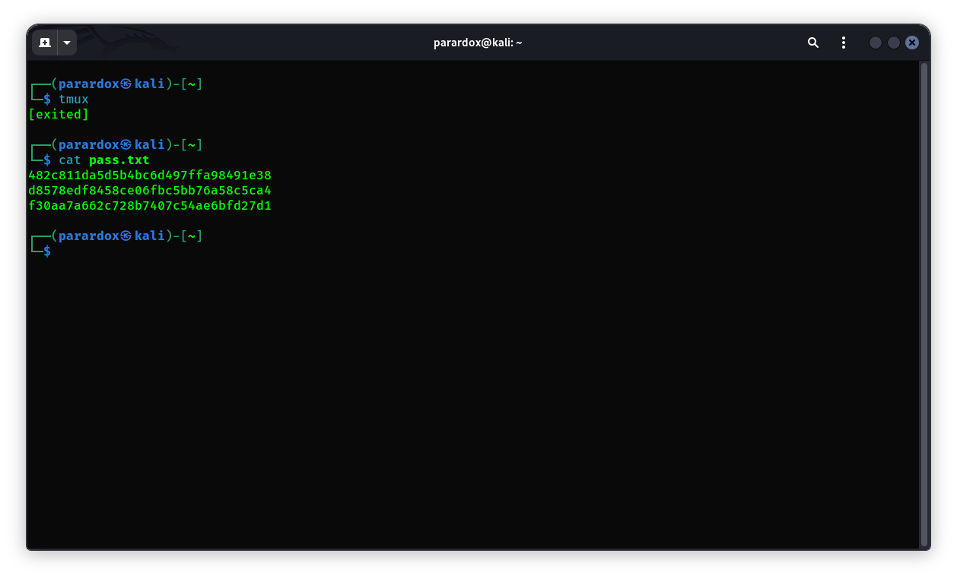

Step 3: Crack using Wordlist Mode

Step 3: Crack using Wordlist Mode
john --format=raw-md5 --wordlist=/usr/share/wordlists/rockyou.txt pass.txt
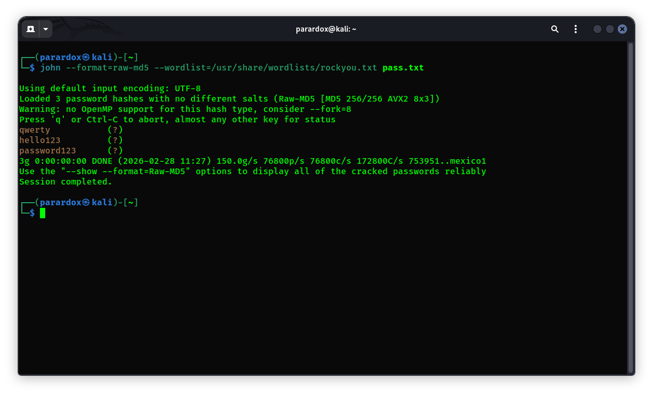
Check cracked passwords:

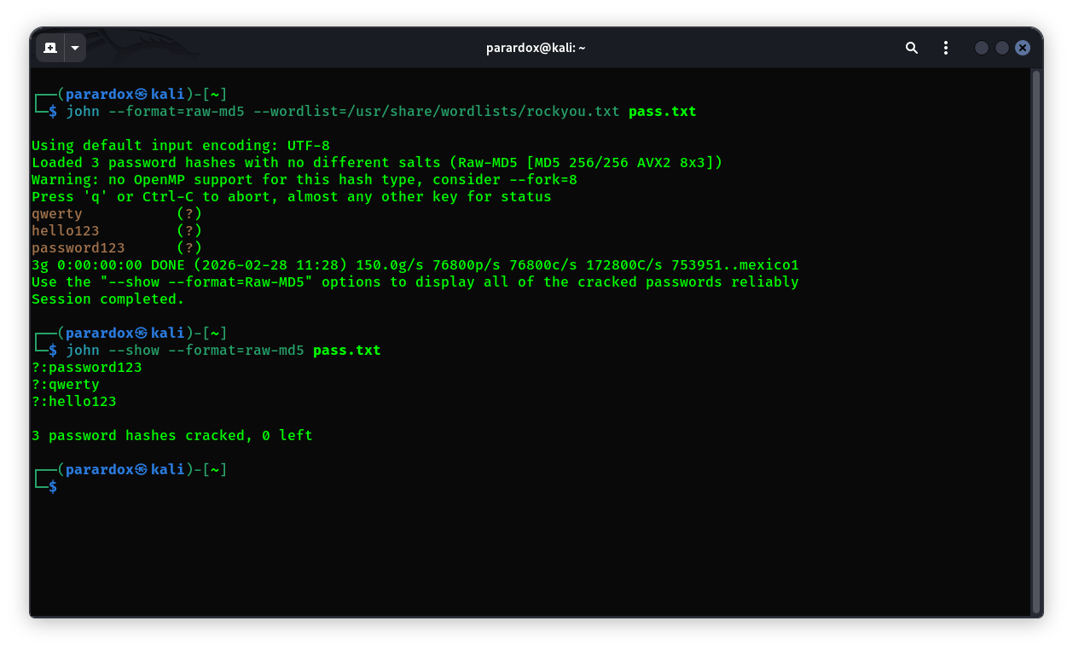

Lab Task 4

How much time does it take?
John automatically shows time.
If passwords are common:
- Cracked in seconds.
If passwords are complex:
- Takes longer.

Why time differs?
Time depends on:
- Password complexity
- Length
- Wordlist size
- CPU speed
- Hash type (MD5 is fast, bcrypt is slow)
- System performance
Weak passwords crack faster because they exist in wordlists

Lab Task 5

Use --rules option
Rules modify wordlist words (add numbers, uppercase letters, etc.)
Run:
john --format=raw-md5 --wordlist=/usr/share/wordlists/rockyou.txt --rules pass.txt
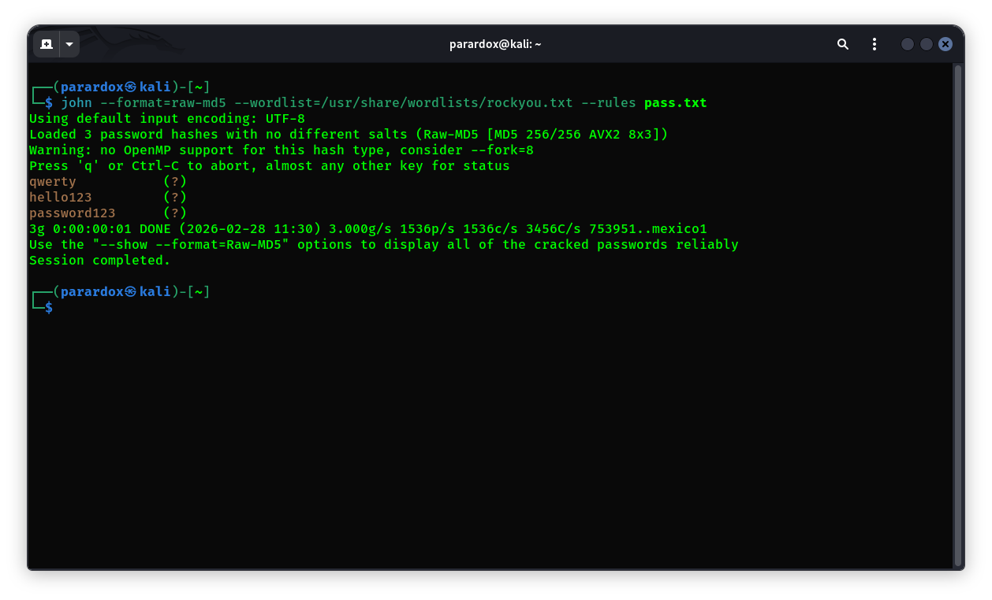
Check results:
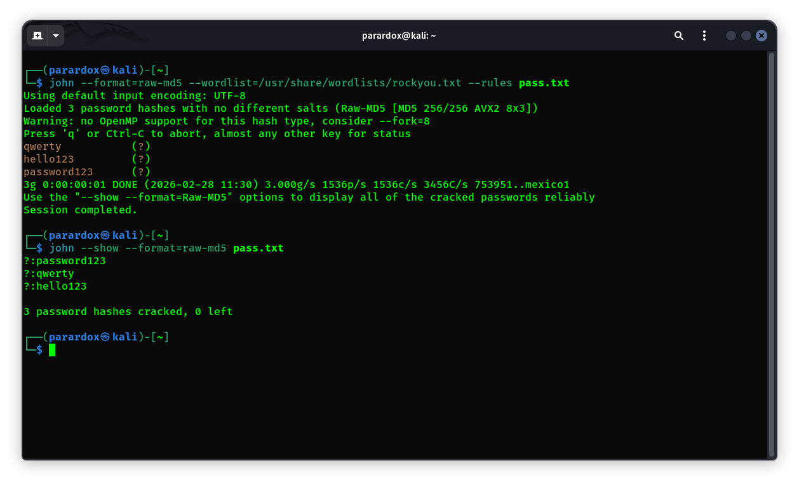

What changes?
- Takes longer than simple wordlist.
- Finds passwords like:
  - password1
  - Password123
  - hello@123
Because rules try variations.

Lab Task 6

Brute Force Mode
Brute force tries ALL combinations.
Run:
john --format=raw-md5 --incremental pass.txt
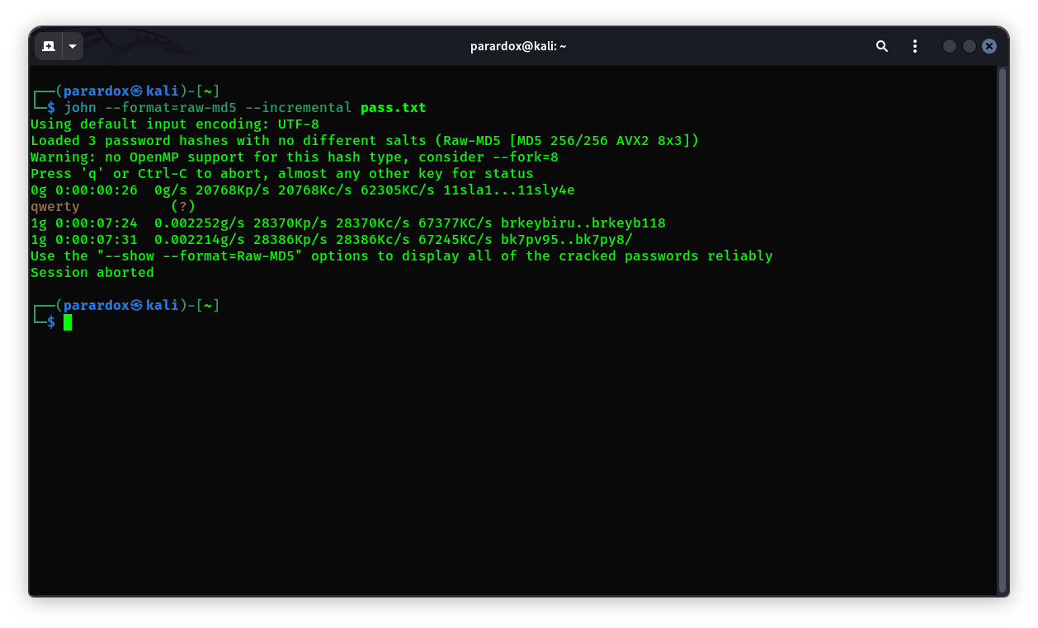

Observation:
- Takes much longer.
- Guaranteed to find short passwords.
- Extremely slow for long passwords.
Stop with:
Ctrl + C
Check results:
john --show pass.txt
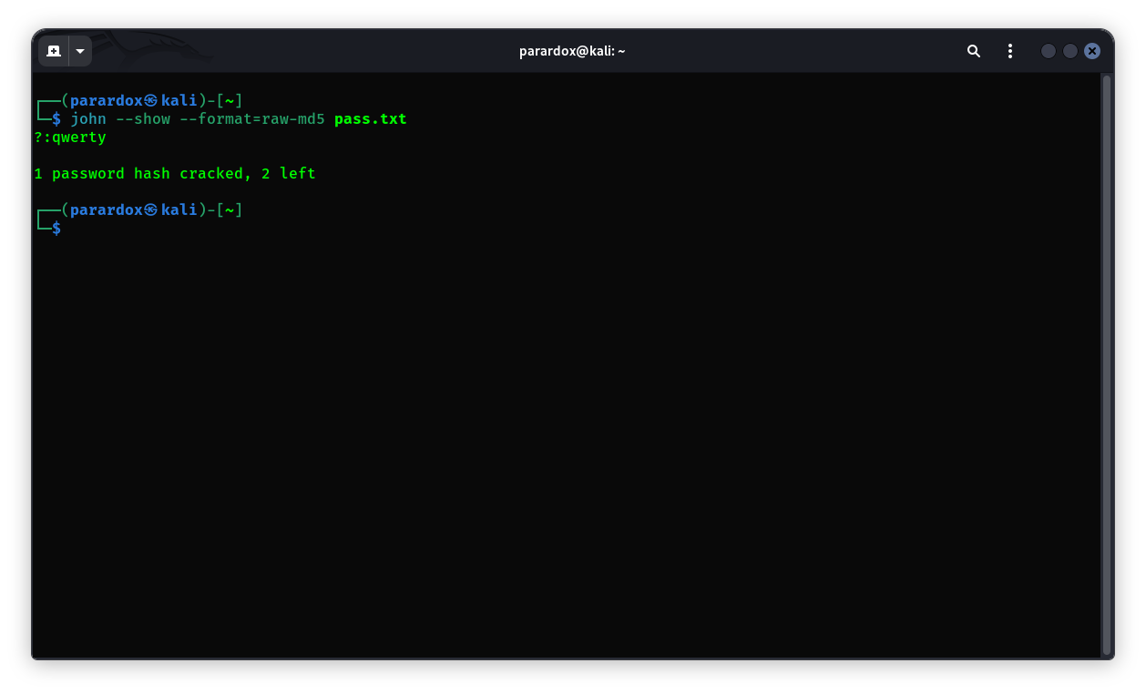

Lab Task 7

Comparison & Reflection

Wordlist Mode
✔ Fast
✔ Works for common passwords
❌ Fails for unique passwords

Wordlist + Rules
✔ Better success rate
✔ Finds modified passwords
❌ Takes more time

Brute Force
✔ Guaranteed if password is short
❌ Very slow
❌ Impractical for long passwords

Importance of Strong Passwords
Strong passwords should:
- Be at least 12–16 characters
- Include uppercase, lowercase, numbers, symbols
- Not be dictionary words
- Not be predictable
Example strong password:
T9#kL$2vQ@7mX!zP
Strong passwords resist:
- Dictionary attacks
- Rule-based attacks
- Brute-force attacks

Conclusion
The experiment shows that weak passwords such as dictionary words or common combinations are cracked within seconds using wordlist attacks. Adding rules increases success rate but also increases cracking time. Brute-force attacks are time-consuming and computationally expensive. Therefore, strong, long, and random passwords significantly improve security against password cracking attacks.

